Systems Development:
Object Oriented
Analysis and Design

H172 35

Assessment
LO 2,3

Student |  | Kamil Milej
I.D. |  | 2264629
Date |  | 4/11/2024
 | Pass |  |  | Fail |  | Remediation
Tutor

Assessment task 2

Outcomes covered 2 and 3

Assessment task instructions

This is an open-book project covering Outcomes 2 and 3.

You are required to create design documentation based on a client brief.
All the Evidence Requirements which you must achieve are detailed after the client brief.
This project will be carried out under supervised and unsupervised conditions, ie you may work on this in your own time. The assessor will check the authenticity of any work you have done unsupervised. This may involve methods such as interviews, demonstrations, checking files, etc and may be carried out at random and pre-arranged times.

The assessor will specify the various deadline periods for the project. It is up to you to determine your own deadlines within these. You may decide to work on multiple tasks at the same time but you should try to fully complete and achieve one stage before completing the next. Applying this method of working is good preparation for the HND Graded Unit.

You should read all the evidence requirements for each stage and clarify any points with the assessor before you commence the project.

You are required to read the brief on the following pages and then complete the stages described after the client brief.

When an item is loaned out to a member, the admin staff will:
- Check the members details to ensure they are a current member – this will involve checking the UserID and password
- Check that the member is not “suspended” – this could happen, for example, if charges for overdue loans have not been paid
- Check that the item has not been reserved by some other member
- Record the details of the item to be loaned
- This might include updating any reservation details

When an item is returned from loan, the admin staff will:
- Retrieve the members list of outstanding loans
- Verify that the item being returned is currently out on loan to that member
- Check to see if the item is overdue
- Calculate any charges due if the item is overdue
- Record the charges as required
- Record if the charge has been paid or not
- Record the details of the item being returned

Stage 1 — Analysis

You are required to analyse the system requirements from the client brief. This could be carried out using various techniques, such as Natural Language Analysis (NLA) (Linguistic Analysis), interviewing the client, research into similar existing systems, or any other suitable techniques.
The outcome of this stage will include:

- Analysis documentation (NLA and/or CRC Cards)
- System-level Use Case Diagram – you should agree this with your lecturer before proceeding to step 3.
- Four or more use case scenarios which include pre and post conditions, trigger event and the best case scenario flow of events. Alternative or exceptional behaviour must be included in at least one use case scenario. You should agree with your lecturer which use cases you intend to develop before proceeding.

Stage 2 — Static model

You are required to produce a static model of the system. The outputs of this stage are:

- a Conceptual Class Diagram that includes:

  - Specification of appropriate association, aggregation and inheritance relationships between classes – this should be agreed with your lecturer before proceeding to the detailed class diagram

- a Detailed Class Diagram that includes attributes and operations showing:

  - Appropriate access modifiers (public, private or protected)
  - Data types
  - Method Parameters where appropriate

Stage 3 — Dynamic model

You are required to produce a dynamic model of the system. The outputs of stage 3 are:

- Sequence diagram showing the flow of messages between objects for the use case of “a member logs in and attempts to reserve a stock item”
- Construction of one other dynamic model diagram from a choice of:
  - Activity
  - Statechart
- The second dynamic model diagram must be appropriate for the scenario; you should discuss the diagram that you intend to develop with your lecturer before commencing.

Submissions Deadlines: Your lecturer will advise you of the submission deadlines for the appropriate stages.

Stage 1 — Analysis

- Lets start our task from split task into smaller tasks. At first, analyse brief and think about understand the main information about of our system, users, access, function/behaviour and all connections. My analyst concentrates on looking for information about actors, use cases and relationships that can be used for the next task. Our goal is to identify classes that need to exist in our system. In linguistic analysis, we read through our requirements and mark all nouns, verbs, and adjectives using a different colour to achieve better transparency. We mark them to use it but not always as a proposition to build our system. Nouns can be potential classes, verbs methods and adjectives as attributes. After that, we should be able to achieve a list of Candidate Classes and concentrate on identifying relevant entities, Identifying responsibilities, allocating responsibilities to entities, identifying relationships between classes, and identifying and analysing scenarios (what needs to happen). We use this analysis because it helps us eliminate of irrelevant terms, the elimination of names of values, the elimination of vague terms, the identification of attributes, the identification of operations and the elimination of terms which are, in fact, related.

nouns
Verbs
Adjectives

The Glencaldy Learning Centre is a community-based Learning Centre and requires a new computer-based system to be designed and built to manage learner and stock data. The Centre is open to the public at advertised times as shown in the appendix. The Centre holds large stocks of various types of media that the public are able to use and/or borrow.

The administration staff (who have a special “admin” login to the system) at the Learning Centre have responsibility for maintaining the media stocks in the Centre, and for administering the loans/returns/reservations of stock items and user records. Another department does the actual ordering of the stock items, and so this is of no immediate concern to us. When the new stock item arrives at the Learning Centre, a staff member will allocate the item a unique StockID, will classify it according to the Centres classification system, and will make the item available to the public. Occasionally the details held about a stock item need to be updated, and a staff member also does this. For each media item title held by the Centre there may be one or multiple copies held. Each copy has its own unique StockID. Sample paper-based records of stock items are shown in the appendix.

The general public is able to access the services available at the Learning Centre in a number of ways. There are three types of membership:
- Full Member
- Casual User
- Staff User

“Full Membership” entitles the member to borrow a maximum of 4 media items at any one time. A copy of the existing paper-based application form for full membership is shown in the appendix.

Staff Members are also enrolled as members of the Centre. For Staff Members the only data we need to store are his/her StaffID, staff email address and internal telephone extension.

The system should store the firstname and surname for all users. Other personal details for staff members are stored in a separate system, and need not be considered just now. Staff members can borrow a maximum of 6 items.

All memberships entitle the member to login and use any of the computers that are available within the Learning Centre.

Users who are not full members or staff can use the facilities but are not allowed to borrow items. We call this type of user a “Casual User”. Before this type of user is allowed to enter the Centre and use the facilities, they also need to be enrolled. A copy of the existing paper-based application form for casual membership is shown in the appendix.

It is envisaged that all users of the Learning Centre (including staff) will be allocated a unique UserID and password. There should also be a facility for passwords to be changed directly by the user.

When an enrolled user (including staff) uses one the computers in the Learning Centre, they will enter their “Login details” into the computer-based system. These details will then be checked to validate their login. Login sessions, storing login date, login time, logout time, and computerID used will be stored for possible future reference. After successful login, the user will be presented with a screen of options appropriate to the type of user.

All users are able to search the catalogue to see if a media item is available.
A variety of different types of searches should be made available.

Staff Members and Full Members are able to borrow an item (up to their maximum quota).

“Casual users” can only use the item within the Learning Centre.

When an item is borrowed, the records are updated to show to which user the item has been loaned. The records are again updated when the item is returned to stock.
Items are initially on loan for a period of 10 days.

If the item is returned after the 10 day period, a fine of 50 pence per day is levied for each day overdue. All fine information should also be stored within the system as appropriate.

It is possible for a user (full and staff) to reserve stock items. Before an item is issued on loan it will therefore be necessary to check first of all to see if that item has been reserved. The member is able to reserve an item him/herself after successfully logging in. The member will search for the item required, and if found, the item will be displayed on the screen. If the item is already reserved, it cannot be reserved until after the first reservation is fulfilled. If it is free to reserve, the user is able to choose to reserve by choosing the appropriate option on the user interface. The reservation details are then updated as appropriate.

The system is required to allow the generation of reports – Stock and Users. These reports will list and show the current status of each instance.

Classes | Methods | Adjectives
StaffUser | Change password, reserve item, return item, borrow item, search media, login in, add new stock | Internal, unique
FullMember | Change password, reserve item, return item, borrow item, search media, login in | unique
CasualUser | Change password, search media, login in | Casual
Loan | Create Loan,  Update Loan | Overdue
Reservation | Check Availability | Reserved, Free
AdminStaff | Manage User, | Unique
Report | Create Report | Current
MediaStock | Check Availability | Various
Catalog | Search Item, List of media
Fine | Calculate Fine | Overdue

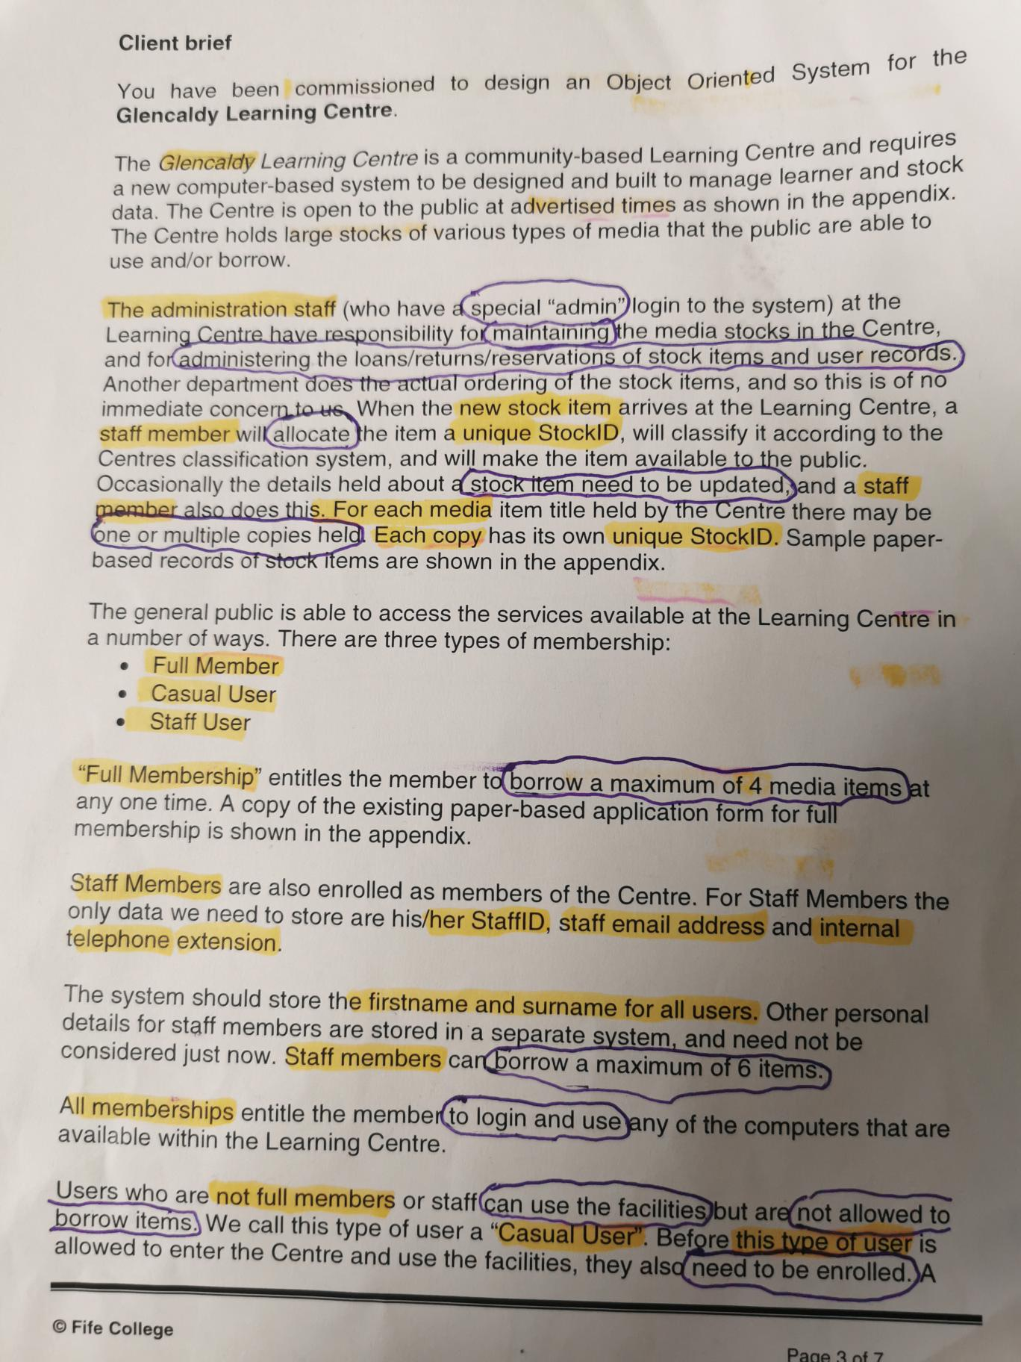

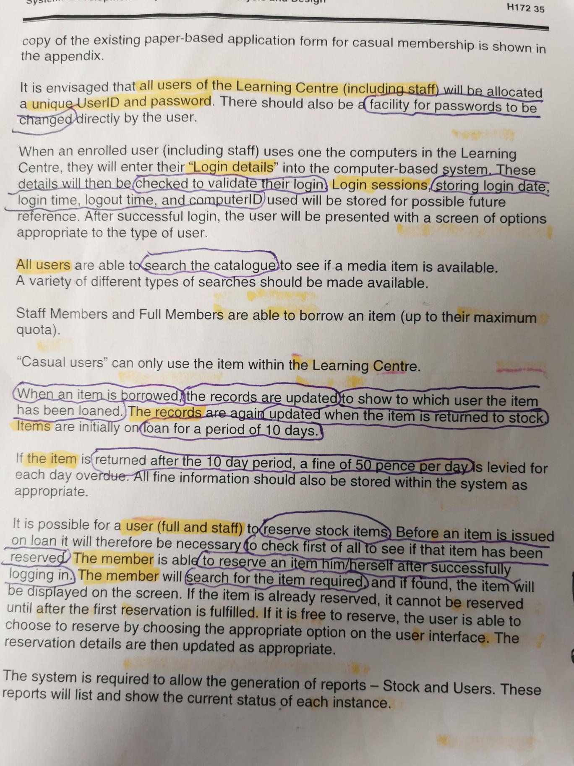

After analysing this file and doing linguistic analysis, I also tried my own version when I just marked what or who and after what function or behaviour I should have to understand more clearly. I decided to finish this paper version because it was more efficient for me, and I understood more. I highlighted the most important information such as:

- Actors
Administration Staff
Full Member
Staff User
Casual User

- Use Cases
Login in
Validate Login
Login Sessions
Error occurred
Search Media
Borrow Item
System records Update
Return Item
Reserve Item
Change password
Manage Fines
Manage Item Stock
Manage Media Stock
Add New Stock
Manage User
Generate Reports
Make copies

- Relationship
Administration Staff have relation with:

Login in
Manage Item Stock
Manage Media Stock
Manage Users
Generate Reports

Full Member have relation with:

Login in
Search Media
Borrow Items (max 4)
Return Items
Reserve items
Change password

Staff Member is related with:

Login in
Search Media
Borrow Items (max 6)
Return Items
Reserve items
Change password
Add new Stock

Casual User is related with:

Login in
Search Media
Change password

- After analysis Client brief we should create Use Case Diagram

At first we need to break down use case diagrams into four different elements:
Systems, Actors, Use Cases and Relationship.

A System is whatever you are developing. It could be everything, website, software components, business process or any app on phone.

Actors is someone or something that uses our system to achieve a goal or complete specific task. That could be a person, organization, external device or even another system. Actors are external objects and need to be placed outside the system, also Actors need to be thought of as types or categories. We have primary actors which initiates the use of the system and secondary acters is more reactionary like bank.

Use case describe what our system does. Represents an action that accomplishes some sort of task within system.

We have few different relationship:

- Association relationship and its basic communication or interaction.
- Include show dependency between a base use and an included use case. every time base use case is executed, the included use case is executed as well or base use case required an included use case in order to be complete.
- Extend will only happen if certain criteria are met, its like extend behaviour of our use case like if we make mistake in log in process then show error massage.
- Generalization relationship also knows as inheritance. We can have generalization of use case but also actors can have it.

- At the end we will do few scenario for the most important operation in our System.

